 | Thanksgiving Pie Sale!

Order a fresh  Delicious Orchards Pie  and pick it up in time for your Thanksgiving Celebrations! | 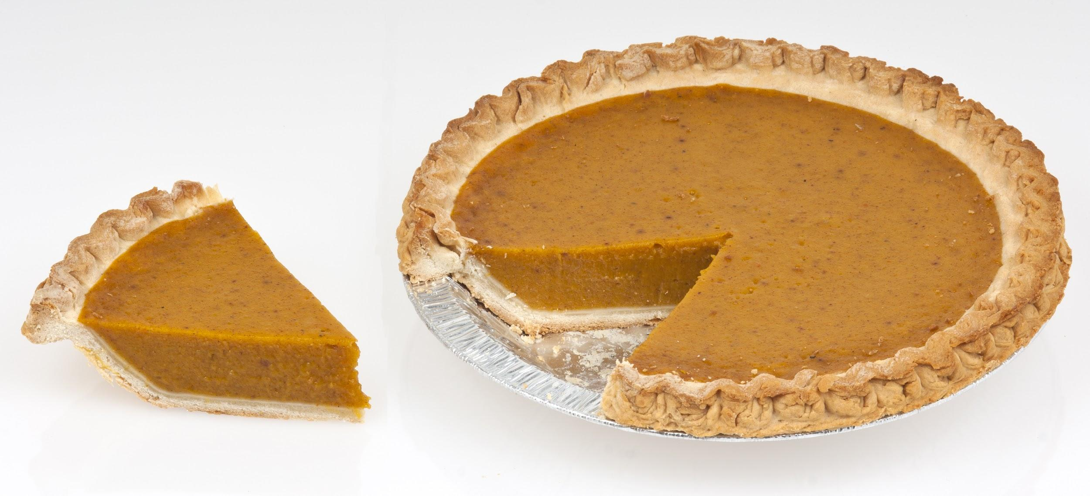

Sponsored by the
St. Clement Youth Group and Delicious Orchards!

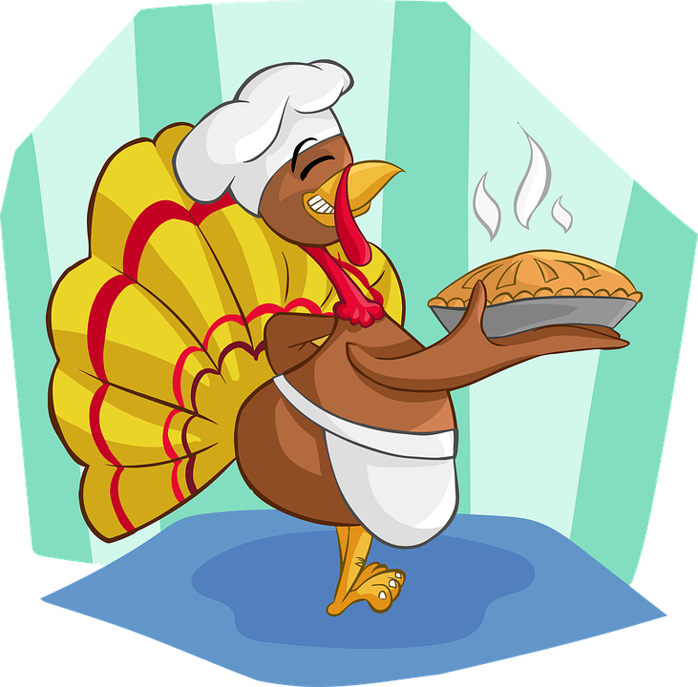 | All pies cost: $20.00 each.  Pies are 9 inch pies (6-8 servings).  There are NO PRESERVATIVES in the pies so they must be kept refrigerated.  .
Orders will be taken before and after all masses in the church lobby on the following weekends:

Sept. 23 & 24th Sept. 30th & Oct. 1st October 7 & 8th

Tentative pie pick up date will be November 20, 21 or 22nd from 4PM-7PM in the St. Clement Gym Lobby. Confirmed pick-up date will be announced via the bulletin. The pies available for order are:

Apple Pie, Pumpkin Pie,
Pecan Pie, Cherry Pie, Sugar Free Apple Pie

Thanksgiving Pie Order Form

Place your order today for a Delicious Orchards pie for your Thanksgiving celebration! All proceeds will benefit the St. Clement Youth Group. All orders are due by October 15th. Cash or checks made out to St. Clement Church will be accepted.

Tentative pie pick up date will be either November 20, 21, or 22nd from 4:00-7:00 PM in the lobby of the St. Clement’s Gym.
Pie | Quantity
Apple
Cherry
Pecan
Pumpkin
Sugar Free Apple

Name: __________________________________________
Phone #: _______________________________________
Total # of pies ordered: ________
Amount Enclosed: _______________

